**Discord Formatting Codes:**[1]

* If you can not find the **asterisk** key on your keyboard, copy this *.
* If you can not find the **underscore** key on your keyboard, copy this _.
* If you can not find the **apostrophe** key on your keyboard, copy this ~.
* If you can not find the **angle bracket** keys on your keyboard, copy this < or >.



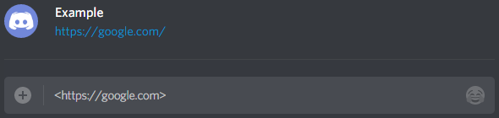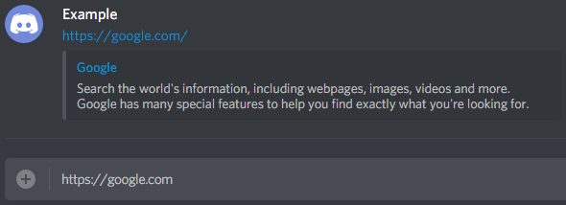

1. **Copyright © 2019** [**Jackson Roy Cope**](https://www.youtube.com/channel/UCe6MiDld2qEdtI8xLeobNnQ)**. All Rights Reserved.**